WCAG 2.2 Level AA Accessibility Audit
Web-Based Authoring Tool: Redacted
Date: May 3, 2026
Reviewer: Caitlin Bartholic

Executive Summary
This report describes the conformance of Redacted templates with Accessibility Guidelines (WCAG 2.2 Level AA). Through manual and evaluation tools several barriers were detected with supplementary issues pinpointed at the end.

Evaluation Methods and Tools Used
- Manual Testing with W3C’s WCAG 2.2 Guidelines
- Keyboard Testing
- VoiceOver Screen Reader
- WebAIM Contrast Checker
- ARC Toolkit
- WebAIM WAVE
- axe DevTools

Severity Ratings
Accessibility barriers are rated using a four-point severity scale.
- Critical: Content or functionality is completely inaccessible to some users.
- Significant: Content or functionality is very difficult for some users.
- Moderate: Content or functionality may require additional time or effort for some users because accessibility or usability guidelines and best practices are not followed.
- Recommendation: Content or functionality can be made more usable for everyone by aligning with best practices.

Global Accessibility Considerations

Focus Indicator on Buttons & Text Fields
WCAG Success Criterion: 1.4.11 Non-text Contrast [Level AA]
Severity Level: Critical
Remarks and Explanations: The focus indicator is always blue. Depending on button color it can be difficult to see. This is a barrier for keyboard users, especially those who have low vision or color blindness. It makes it difficult to see which element has current keyboard focus.
Recommendations:
Create a two-color focus indicator with two solid bands of color that have a 9:1 contrast ratio with each other. This will ensure it meets the requirement of at least 3:1 contrast between the indicator and adjacent colors.
The focus indicator could be a straight edged rectangle to around the entirety of the rounded buttons with some background showing between the button and focus indicator, rather than conform to the shape.
Keep the focus indicator consistent on all items in the tab order, including text fields.
Test with various background and button colors.


Button Labels
WCAG Success Criterion: 4.1.2 Name, Role, Value [Level A]
Severity Level: Critical
Remarks and Explanations: Button elements (like previous, next, submit, skip, add) lack a programmatic name. This is a barrier for people who are blind/low vision and use screen readers. When on a large enough screen, the “prev” and “next” text is readable by a screen reader, but on smaller screens the text is gone and removes any indicator of button function. Without the programmatic name, the full context of the buttons is not available to these users.
Recommendations: Ensure all buttons have programmatic labels.
For example, the current code for a previous button begins with:
<button class="
px-4
rounded-4xl
font-semibold
cursor-pointer
_button_1pjk7_1
undefined
" style="

This could be changed to:

<button
aria-label="Previous"
class="
px-4
rounded-4xl
font-semibold
cursor-pointer
_button_1pjk7_1
undefined
"
style="

For + button labels to add text fields, add labels for those buttons with a description such as: <button aria-label="Add another response">
More about button formatting for accessibility from DeQue University

Non-active Elements in Tab Order
WCAG Success Criterion: 4.1.2 Name, Role, Value [Level A]
Severity Level: Critical
Remarks and Explanations: Some text elements on slides are included in the tab focus order but have no role. When an element can receive focus with a focus indicator, it implies the element has a role. This is a barrier for people who use a keyboard to navigate, including those who rely on screen readers.
Recommendations: Remove any elements without a role from the focus order. In the code you may see: tabindex=”0”where the element is placed in the natural tab order and shouldn’t be. All items in the tab order should have an assigned role attribute. Two examples are shown below.
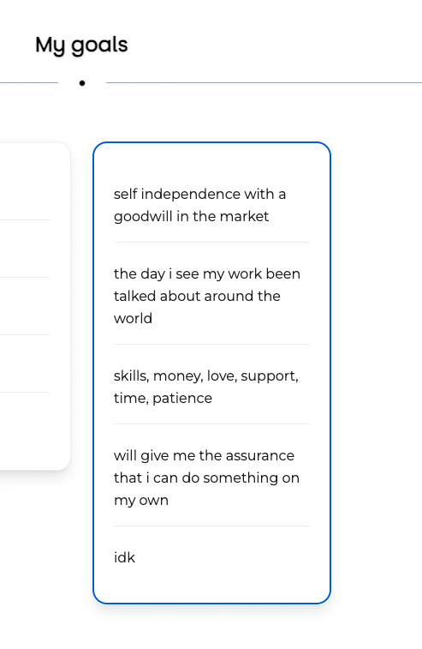
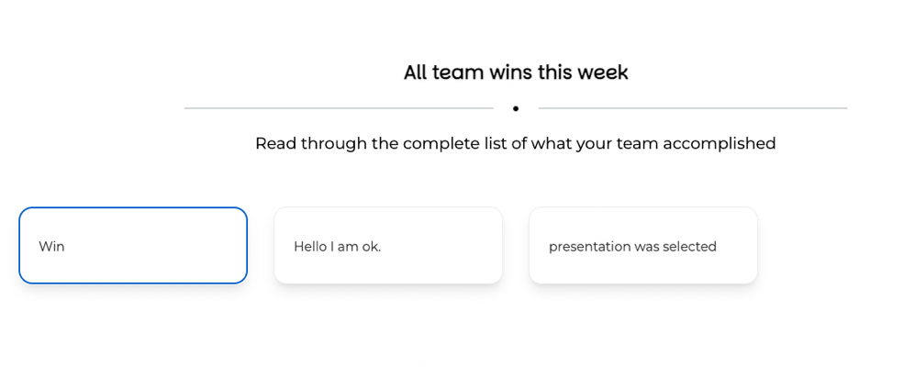

Radio Buttons Not Selectable
WCAG Success Criterion: 2.1.1 Keyboard [A]
Severity Level: Critical
Remarks and Explanations: Radio button responses on slides are not keyboard selectable. These are read to a screen reader as text with no indication they are buttons. This is a barrier to people using keyboards and other assistive technology for navigation, including screen readers.
Recommendations: Make sure all interactive elements on every slide are keyboard selectable.
Example from Confidence Vote template shown below.
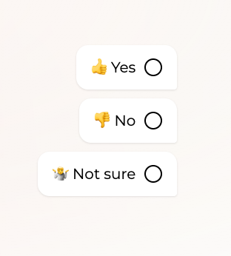

Missing Labels for Form Elements, or Placeholders used for Visual Labels
WCAG Success Criterion: 1.3.1 Info and Relationships [A] , 3.3.2 Labels or Instructions [Level A]
Severity Level: Critical
Remarks and Explanations: Form elements are missing labels. In some places it is identified as “required” but no other indication as to the input expected. The placeholder=”…” code only serves to provide visual cues inside the text field for sighted users. Screen readers may read the placeholder text, but this is not consistent. It usually disappears as soon as typing begins with no reference for what the field was. This is a barrier for people who use screen readers.
Recommendations: Make sure all form fields have consistent, programmatic labels. This way people using screen readers will have access to the information needed for the form while they are actively focused on that part of the form. Use <label for= and <input type=
Here is an example from the “Brainstorming session” template. (The item name is used as it appears currently but can be changed to describe the input field).
Before the input field, add:
<label for="084f1520-70b4-4f06-832e-813f0118e39c">
Share your first idea here
</label>
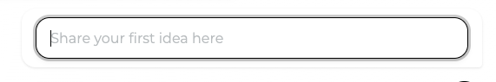
Here is an example from the SMART Goals Generator.
While the focus is on the previous form input, the screen reader is reading the information announcing the next form input due to the lack of labels.
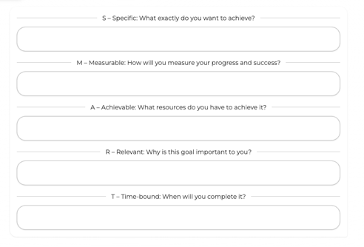

Find examples of how to code this on DeQue University’s Form elements must have labels.

Specific Suggestions by Template
Template: Collaborative SWOT Analysis
Page: Explore our collaborative analysis
Remarks and Recommendations: Add an alternative to wheel for screen reader users as the wheel is difficult to navigate with a screen reader, and add alt text with instructions. Example: SWOT Analysis wheel showing Strengths, Weaknesses, Opportunities, and Threats entered by users. Results in accessible table on next slide.

Template: Collaborative SWOT Analysis
Page: Contribute to our SWOT
Remarks and Recommendations: Change “Contribute to our SWOT” to “Contribute to our S.W.O.T.” so it will be read properly by screen readers. Add the definition for the S.W.O.T. acronym before the form entries. For the form entries, the current tab order is Strengths, Threats, Weaknesses, Opportunities. Following S.W.O.T. and reading left to right and top to bottom, it should be Strengths, Weaknesses, Opportunities, Threats.
(Same issue on Remote Work Preferences template “How do you prefer to communicate?” page and Design Thinking Workshop “Empathize” page).

Template: Collaborative SWOT Analysis
Page: Out top priorities
Remarks and Recommendations: Simple typo – change “Out” to “Our”
The resulting words on this slide are read by a screen reader – follow this method for other slides as they don’t all read the resulting words.

Other Comments/Suggestions/Questions

Button Color/Theme
The button color in the theme becomes the text color for slide navigation buttons (previous, submit, next) and the button text color in theme becomes the button color for the slide navigation buttons. It would be great to be able to customize this as I like one set for the buttons on my slide, but don’t necessarily want the opposite for the navigation buttons. For example, in a theme I created I chose blue as the button color and purple as the button text, but it automatically made the navigation buttons the opposite, which I don’t like. Having the option to choose both button text colors and background colors would be an improvement.


Backgrounds
I love that the chosen background from the Background Library blends well with the chosen background color for the theme when using similar colors. It would be great to have the option to make some of the backgrounds available more as “frames” for slides while keeping the full chosen background color. It would also be helpful to be able to choose a background and apply it to multiple or all slides in a presentation rather than just one at a time (I didn’t see that as an option).

Customization
Adding the option for more detailed design options and customization would be a great future feature. For example, allowing the designer to customize slide layout rather than having to stick with one of the provided options. Being able to change the color of the background or text on specific slides within the same presentation would be a nice feature as well.

Fonts & Sizes
Having options for large, medium, and small fonts is helpful, and being able to choose different fonts for titles and body text is a great option. From an accessibility perspective it would be great to be able to identify the exact font size on the slides, and have the option to make text even larger for titles.

Responses/Results
Being able to access results from user responses, and downloading as a csv is a great feature. It would be even better if results for an entire presentation were downloadable, rather than accessing each individual slide to see the results and export them.

Simplicity
I really appreciated the simplicity in being able to apply a theme and create a presentation using templates or adding elements myself. It is simple and efficient, and allows for the designer to add a combination of elements within one presentation.

Sliders
The sliders (as in Remote work preferences) with alternative options for entering text are great. This makes them more accessible and easier to use. Being able to adjust values and add value references is also a great feature. Make sure a screen reader user will have a description of how to enter information (see forms in audit above).

Templates
Having all of the templates available is not only a great way to get started, but can help designers see different features and what is possible in Redacted. I really enjoyed perusing through the templates, and the template request feature is a nice addition.

Themes
I love the option to create and apply multiple themes. This make the process much more efficient and is a huge bonus to anyone working with branding. Logo options in themes is a great addition as well.

